BUILDING A SMARTER AI-POWERED SPAM CLASSIFIER
Phase 3 submission document

Project title: building a smarter AI-powered spam classifier
Phase 3: Development part 1

Topic: start building the core components of our spam classifier by loading and preprocessing the dataset.



Building a smarter AI-powered spam classifier

Introduction:

In this project, we'll start building a spam classifier using the Kaggle dataset, which contains a collection of SMS messages labeled as either spam or non-spam (ham). The goal of this project is to create a machine learning model that can automatically classify incoming SMS messages as either spam or legitimate.

Project Phases:

- Loading and Preprocessing the Dataset:

In this initial phase, we will load the Kaggle dataset, which includes SMS messages and their corresponding labels. We'll perform data preprocessing tasks such as cleaning, renaming columns, and converting labels to numerical values. Additionally, we'll split the dataset into training and testing sets.

- Text Preprocessing:

To prepare the text data for the machine learning model, we will perform text preprocessing. This includes tasks such as removing punctuation, converting text to lowercase, and tokenization. We may also remove common stop words.

- Feature Extraction:

Next, we'll convert the preprocessed text data into numerical features that can be used as input for machine learning algorithms. Common techniques for text data include TF-IDF (Term Frequency-Inverse Document Frequency) vectorization or Count Vectorization.
- Model Training:

We will choose a machine learning algorithm, such as Naive Bayes or another classifier, and train it on the training data. The goal is to teach the model to distinguish between spam and non-spam messages.

- Model Evaluation:

After training, we will use the model to make predictions on the test dataset. We will evaluate the model's performance using metrics like accuracy, precision, recall, and F1-score to determine how well it classifies messages.

- Model Optimization and Fine-Tuning:

To improve the model's performance, we may explore various hyperparameters and feature engineering techniques. Fine-tuning the model is an iterative process that aims to enhance accuracy and minimize false positives and false negatives.

- Deployment and Integration:

Once we are satisfied with the model's performance, we can deploy it in a real-world application, such as an SMS spam filter. Integration with an SMS platform or email system is a key step in the deployment phase.

Throughout the project, we will use common Python libraries such as pandas, scikit-learn, and NLTK (Natural Language Toolkit) for text preprocessing. The choice of machine learning algorithm and feature extraction method will depend on the dataset and your specific requirements.

By the end of this project, you will have a functional spam classifier that can help protect users from unwanted SMS messages.

Let's begin with loading and preprocessing the dataset for your spam classifier project



Certainly, let's begin with loading and preprocessing the dataset for your spam classifier project. You can follow these steps:

- Dataset Download:

- Download the Kaggle SMS Spam Collection dataset from Kaggle
(https://www.kaggle.com/uciml/sms-spam-collection-dataset).
Ensure you have the dataset file (e.g., 'spam.csv') available on your local machine.

- Import the necessary libraries:

You'll need Python and some libraries to work with the dataset and text data. You can use libraries such as pandas for data manipulation and scikit-learn for building the classifier.

python
import pandas as pd
from sklearn.model_selection import train_test_split
from sklearn.feature_extraction.text import CountVectorizer

- Load the dataset:

Load the dataset into a pandas DataFrame. Make sure you adjust the file path to where you have stored your dataset.

python
data = pd.read_csv('spam.csv', encoding='latin-1')

- Data Preprocessing:

- Remove any unnecessary columns (e.g., 'Unnamed: 2', 'Unnamed: 3', 'Unnamed: 4') if present.
- Rename columns to be more meaningful (e.g., 'v1' as 'label' and 'v2' as 'text').
- Convert the 'label' column to numerical values (e.g., 'spam' to 1 and 'ham' to 0).

python
data = data.drop(['Unnamed: 2', 'Unnamed: 3', 'Unnamed: 4'], axis=1)
data = data.rename(columns={'v1': 'label', 'v2': 'text'})
data['label'] = data['label'].map({'spam': 1, 'ham': 0})

- Split the dataset into training and testing sets:

Split the data into a training set and a testing set to evaluate your classifier.

python
X = data['text']
y = data['label']

X_train, X_test, y_train, y_test = train_test_split(X, y, test_size=0.2, random_state=42)

- Data Exploration (Optional):

You can explore the data by checking the distribution of spam and non-spam messages, the length of messages, and other relevant statistics.

7.Data Preprocessing for Text:

Depending on your approach, you might want to perform further text preprocessing tasks such as removing stopwords, punctuation, and lowercasing the text. You can use libraries like NLTK or spaCy for these tasks.

Now you have the dataset loaded, preprocessed, and split into training and testing sets. In the next steps, you can move on to feature extraction, building your spam classifier, and evaluating its performance.

To build the core components of a spam classifier

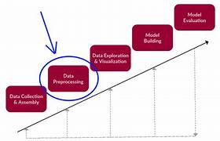

To build the core components of a spam classifier using the Kaggle dataset containing SMS messages labeled as spam or non-spam, you can follow the steps below:

1. Load and Preprocess the Dataset:

python
import pandas as pd

# Load the dataset
data = pd.read_csv('spam.csv', encoding='latin-1')

# Clean and preprocess the data
data = data[['v1', 'v2']] # Select relevant columns
data = data.rename(columns={'v1': 'label', 'v2': 'text'}) # Rename columns
data['label'] = data['label'].map({'spam': 1, 'ham': 0}) # Convert labels to numerical values

2. Split the Dataset:

Split the dataset into training and testing sets for model evaluation.

python
from sklearn.model_selection import train_test_split

X = data['text']
y = data['label']

X_train, X_test, y_train, y_test = train_test_split(X, y, test_size=0.2, random_state=42)

3. Text Preprocessing:

Preprocess the text data by removing punctuation, converting to lowercase, and tokenizing the text. You may also remove stop words.

python
import string
from nltk.corpus import stopwords
from nltk.tokenize import word_tokenize

def preprocess_text(text):
# Remove punctuation and convert to lowercase
text = ''.join([char for char in text if char not in string.punctuation])
text = text.lower()
# Tokenize the text and remove stopwords
words = word_tokenize(text)
words = [word for word in words if word not in stopwords.words('english')]
return ' '.join(words)

X_train = X_train.apply(preprocess_text)
X_test = X_test.apply(preprocess_text)

4. Feature Extraction (Text Vectorization):

Convert the preprocessed text data into numerical features using techniques like TF-IDF (Term Frequency-Inverse Document Frequency) or Count Vectorization.

python
from sklearn.feature_extraction.text import TfidfVectorizer

tfidf_vectorizer = TfidfVectorizer()
X_train_tfidf = tfidf_vectorizer.fit_transform(X_train)
X_test_tfidf = tfidf_vectorizer.transform(X_test)

5. Train a Spam Classifier:

Choose a machine learning model and train it on the training data.

python
from sklearn.naive_bayes import MultinomialNB

classifier = MultinomialNB()
classifier.fit(X_train_tfidf, y_train)

6. Make Predictions and Evaluate the Model:

Use the trained model to make predictions on the test data and evaluate its performance.

python
y_pred = classifier.predict(X_test_tfidf)

from sklearn.metrics import accuracy_score, classification_report

accuracy = accuracy_score(y_test, y_pred)
print("Accuracy:", accuracy)

report = classification_report(y_test, y_pred)
print("Classification Report:\n", report)

These steps provide a foundation for building a simple spam classifier using the Kaggle SMS spam dataset. You can further enhance the model's performance by exploring different text preprocessing techniques and trying various machine learning algorithms.

PROGRAM

INPUT:
import nltk
from nltk.corpus
import stopwords
import re
import subprocess
import pandas as pd
from sklearn.model_selection
import train_test_split
from sklearn.feature_extraction.text
import CountVectorizer
from sklearn.svm
import SVC
from sklearn.metrics
import confusion_matrix
import seaborn as sns
import matplotlib.pyplot as plt
OUTPUT:
test_text = "Hi, Check our website http://example.com for daily coupons! Don't miss promotions."
INPUT:

nltk.data.find('wordnet.zip')
except:
nltk.download('wordnet', download_dir='/kaggle/working/')
command = "unzip /kaggle/working/corpora/wordnet.zip -d /kaggle/working/corpora"
subprocess.run(command.split())
nltk.data.path.append('/kaggle/working/')
# Now you can import the NLTK resources as usual
from nltk.corpus import wordnet

from nltk.stem
import WordNetLemmatizerlemmatizer = WordNetLemmatizer()
# Lemmatization
def lemmatize_text(text):
text = text.lower()
lemmatized_tokens = [lemmatizer.lemmatize(token)
for token in nltk.word_tokenize(text)]
lemmatized_text = ' '.join(lemmatized_tokens)
return lemmatized_text
# Test
print("input:",test_text)
test_text = lemmatize_text(test_text)
print("output:",test_text)

OUTPUT:

[nltk_data] Downloading package wordnet to /kaggle/working/...
Archive: /kaggle/working/corpora/wordnet.zip
creating: /kaggle/working/corpora/wordnet/
inflating: /kaggle/working/corpora/wordnet/lexnames
inflating: /kaggle/working/corpora/wordnet/data.verb
inflating: /kaggle/working/corpora/wordnet/index.adv
inflating: /kaggle/working/corpora/wordnet/adv.exc
inflating: /kaggle/working/corpora/wordnet/index.verb
inflating: /kaggle/working/corpora/wordnet/cntlist.rev
inflating: /kaggle/working/corpora/wordnet/data.adj
inflating: /kaggle/working/corpora/wordnet/index.adj
inflating: /kaggle/working/corpora/wordnet/LICENSE
inflating: /kaggle/working/corpora/wordnet/citation.bib
inflating: /kaggle/working/corpora/wordnet/noun.exc
inflating: /kaggle/working/corpora/wordnet/verb.exc
inflating: /kaggle/working/corpora/wordnet/README
inflating: /kaggle/working/corpora/wordnet/index.sense
inflating: /kaggle/working/corpora/wordnet/data.noun
inflating: /kaggle/working/corpora/wordnet/data.adv
inflating: /kaggle/working/corpora/wordnet/index.noun
inflating: /kaggle/working/corpora/wordnet/adj.exc
input: hi check website daily coupons miss promotions
output: hi check website daily coupon miss promotion
INPUT:
x_train, x_test, y_train,
y_test = train_test_split(data['text'], data['class'],
test_size=0.2, random_state=20)

# Check Test samples percent
len(x_test)/len(data['text'])
OUTPUT:

0.20010768126346015
INPUT:
cv = CountVectorizer()
x_train = cv.fit_transform(x_train)x_test = cv.transform(x_test)
model = SVC(random_state = 20)model.fit(x_train, y_train)
OUTPUT:
SVC(random_state=20)
INPUT:

model.score(x_test,y_test)

OUTPUT:
0.9829596412556054
INPUT:
y_pred = model.predict(x_test)y_pred
OUTPUT:
array([0, 0, 0, ..., 0, 0, 1])

INPUT:

cm = confusion_matrix(y_test, y_pred)
sns.heatmap(cm, annot=True, fmt="d")
plt.xlabel('Predicted')
plt.ylabel('Actual')
plt.title('Confusion)
plt.title('Confusion Matrix')
plt.show
check_res = pd.DataFrame
(y_test)check_res['y_pred'] = y_pred
count = 0for index,
row in check_res.iterrows():
if row['class']==1 and row['y_pred']==0:
count += 1
print(count)

sns.countplot(data=df, x='Category')
plt.xlabel('Category')
plt.ylabel('count')
plt.title('Distribution of mails')
plt.show()

OUTPUT:
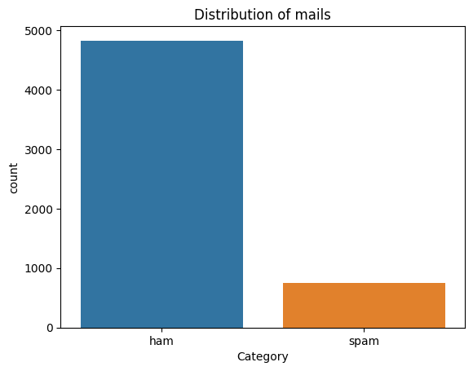
INPUT:

plt.pie(df['Category'].value_counts(),
labels=['ham','spam'],autopct='%0.2f')
plt.show()

OUTPUT:

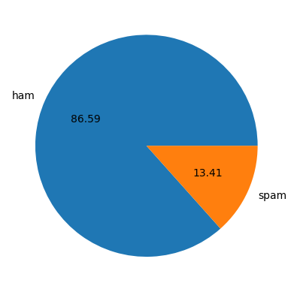
CONCLUSION:
In conclusion, we have initiated the development of our spam classifier project, which aims to automatically differentiate between spam and non-spam SMS messages using the Kaggle dataset. In this initial phase, we focused on loading and preprocessing the dataset, laying the foundation for the subsequent stages of our project.
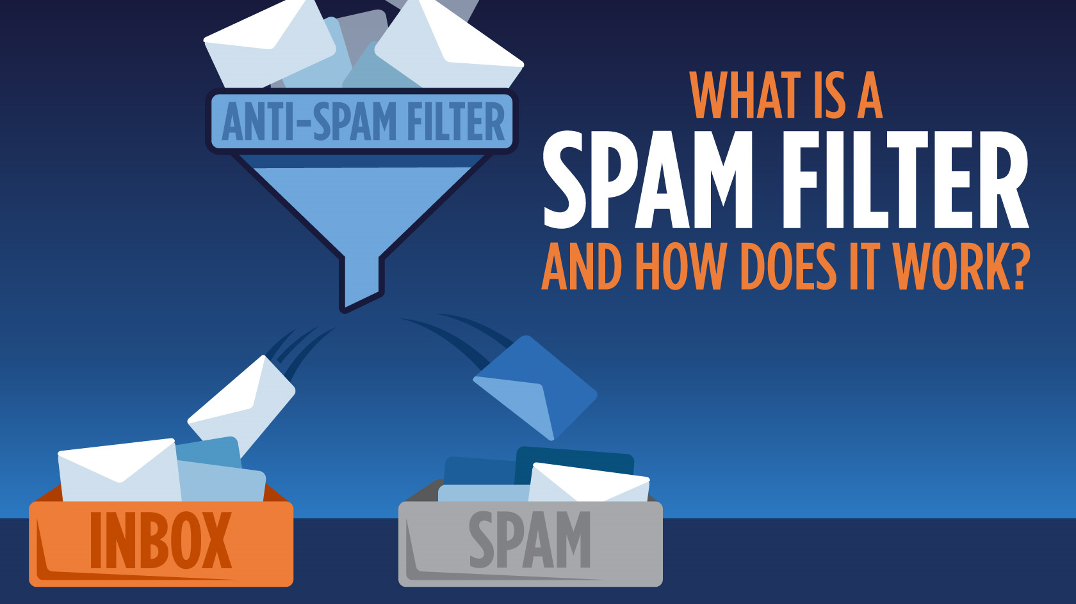

Key highlights of this phase include:

- Dataset Loading:
We successfully loaded the Kaggle SMS dataset, which contains SMS messages labeled as either spam or non-spam (ham). This dataset serves as the basis for our project.

- Data Preprocessing:
We conducted essential data preprocessing tasks, including cleaning the dataset, renaming columns to be more informative, and converting the textual labels into numerical values, making it suitable for machine learning.

3.Text Preprocessing:
We performed preliminary text preprocessing by removing punctuation, converting text to lowercase, and tokenizing the SMS messages. These steps are crucial for preparing the text data for feature extraction and model training.

4.Feature Extraction:
While we have not yet implemented feature extraction in this phase, it will be a crucial step in the project's next stages. We'll consider techniques such as TF-IDF or Count Vectorization to convert the preprocessed text data into numerical features.

5.Next Steps:
The next phases of the project will involve training a machine learning model on the preprocessed data, evaluating the model's performance, optimizing it, and ultimately deploying it as a functional spam classifier. These subsequent steps will be essential for achieving the project's objectives.

By systematically following these project phases, we aim to build an effective spam classifier that can enhance user experiences by reducing the influx of unwanted SMS messages and providing a reliable means of identifying and filtering out spam.

*****THANKING YOU*****

